Sample assessment task

Mathematics Applications – ATAR Year 12

Investigation 1 – Unit 3
Assessment type: Investigation
This investigation reviews the statistical investigation process: identify a problem; pose a statistical question; collect or obtain data; analyse data; interpret and communicate results.

Notes for teachers
- It is assumed the class has the appropriate access to technology for data handling, such as CAS calculators or spreadsheets.
- The teacher may decide the best type of technology suitable or available for the purpose of the investigation, and modify the scope of the questions to suit.
- This investigation is set to coordinate with the teaching of the Topic 3.1 Bivariate data analysis.
- Students should have been taught the concepts and skills required for each section of the Investigation, especially the use of appropriate software.

Conditions: Time for the task: to take home/or in class over one week

Materials required: Internet access
Calculator and/or computer with appropriate software

Other materials allowed: Tape measures

Marks available: 23 marks

Task weighting: 1% (+ 4% for validation) for the pair of units
__________________________________________________________________________

INTRODUCTION
CensusAtSchool was a nation-wide project that collected real data from students by way of an online questionnaire. It provided a snapshot of the characteristics, attitudes and opinions of those students who completed questionnaires from 2006 to 2014. It can be located online:
http://www.abs.gov.au/websitedbs/CaSHome.nsf/Home/Home
While the database is very large, you can sample the results of the survey to allow you to answer statistical questions posed.
For example, archaeologists/forensic experts often unearth skeletons which are not complete. The proposition is that we can predict the height of a skeleton using the arm span.

Task 1 (3 marks)
(a) Go to CensusAtSchool, using the link above, and download a random sample with n~50 of the complete list of variables for the 2014 Questionnaire. This is the database you will use when completing the various tasks and questions.
(b) State the survey questions (variables) to help you consider the proposition: It is possible to use the length of an arm span of a body to estimate the height of that individual.

(c) State the explanatory variable and the response variable.

Task 2 (9 marks)
(a) Document how you will go about selecting and presenting the data from your downloaded database.
(b) Calculate the statistical measures you will use to decide whether the proposition is reasonable or not.

Task 3 (5 marks)
Use the statistical results from Task 2 to decide whether the proposition is reasonable or not and, if so, how you would use these measures.

Task 4 (6 marks)
Test your results from Task 2 by collecting data from your fellow students and demonstrate how you would use the second data set to support or challenge your answer in Task 3.

Marking key for Investigation 1 – Unit 3

Task 1
(a) Go to CensusAtSchool, using the link above, and download a random sample with n=50 of the complete list of variables for the 2014 Questionnaire. This is the database you will use when completing the various tasks and questions.
(b) State the survey questions (variables) to help you consider the proposition: It is possible to use the length of an arm span of a body to estimate the height of that individual.
(c) State the explanatory variable and the response variable.

Solution
(a) See Appendix 1 for the full list of questions

(b) Question 9 – How tall are you without your shoes on? (nearest cm)
Question 11 – What is your arm span? (nearest cm)

(c) Arm span is the explanatory variable and Height is the response variable.

Behaviours | Marks | Item*  (S/C)
Supplies the list of questions used in the 2014 survey  Chooses the required Questions 9 and 11 from the survey  Indicates Arm span as the explanatory variable and Height as the response variable | 1  1  1 | simple  simple  simple

Task 2
(a) Document how you will go about selecting and presenting the data from your downloaded database.
Solution
Step 1 Copy bivariate data for Height and Arm span with sample size n~ 50 into a separate spreadsheet. (See Appendix 2)

Step 2: Use the software to draw a scatter graph with Height and Arm span.

Step 3: Delete any outliers using the scatter graph to choose them n~ 47.

Behaviours | Marks | Item*  (S/C)
Selects the two variables to set up a scatter plot  Draws the scatter plot with the appropriate software  Deletes appropriate outliers from scatter plot | 1  1  1 | simple  simple  simple

(b) Calculate the statistical measures you will use to decide whether the proposition is reasonable or not.
Solution
Step 4: Calculate the linear regression equation with edited graph (See Appendix 3)

Step 5: Calculate the correlation coefficient (r=0.896) and the coefficient of determination (r²=0.801)
(See Appendix 3)

Step 6: Plot a graph of residuals to check the appropriateness of the linear model
(See Appendix 4)

Behaviours | Marks | Item*  (S/C)
Accurately calculates the linear regression line  Accurately calculates correlation coefficient (r) and the coefficient of determination (r²)  Calculates the residuals of the data points  Refers to the random pattern of residual plot | 2  2  1  1 | simple  simple  simple  simple

Task 3
Use the statistical results from Task 2 to decide whether the proposition is reasonable or not and, if so, how you would use these measures.
Solution
r=0.896 indicates a strong positive relationship
Hence, any increase in Arm span indicates an increase in Height.
The residual plot indicates that the linear regression fit is appropriate. (See Appendix 4)
r²=0.802 also suggests that the regression line is a good predictor of Height given
Arm span.
Therefore, the proposition is reasonable.
We can use the equation to predict height (y) given an arm span length (x)
e.g. x=145 then
Behaviours | Marks | Item*  (S/C)
Uses the correlation coefficient to indicate a strong positive relationship  Uses the residual to check the appropriateness of the linear model  Comments the coefficient of determination indicates the regression line is a good predictor  States the proposition is reasonable  Gives a worked example | 1  1  1  1  1 | simple  simple  simple  simple  simple

Task 4
Test your results from Task 2 by collecting data from your fellow students and demonstrate how you would use the second data set to support or challenge your answer in Task 3.
Solution
Q11. Arm span | Q09. Height | y-fitted | X | Residual
145 | 153 | 150 | 1 | 3
160 | 162 | 163 | 2 | -1
129 | 147 | 137 | 3 | 10
157 | 146 | 160 | 4 | -14
187 | 187 | 185 | 5 | 2
172 | 170 | 173 | 6 | -3
160 | 166 | 163 | 7 | 3
162 | 165 | 164 | 8 | 1

The pattern of residuals suggests the linear model is appropriate.
The measurements of the eight students indicate that the fitted value is often reasonably close to the actual measured value. The two outliers may be due to a mistake in measuring?
(Note – these measurements were taken from the sampler on a different occasion.)
Behaviours | Marks | Item*  (S/C)
Sets up a table for a separate group for Arm span versus Height  Calculates the Fitted height of these individuals  Calculates the residuals of the data points  Refers to the random pattern of residual plot  Compares the Actual height to Fitted height  States that there is a reasonably good match | 1  1  1  1  1  1 | simple  simple  simple  simple  simple  simple

Sample assessment task

Mathematics Applications – ATAR Year 12

Investigation validation 1 – Unit 3
Assessment type: In-class Investigation
This investigation reviews the statistical investigation process: identify a problem; pose a statistical question; collect or obtain data; analyse data; interpret and communicate results.

Notes for teachers:
- It is assumed your class has the appropriate access to technology for data handling.
- This in-class investigation reflects the work carried out in the extended part.

Conditions: Time for the task: Up to 50 minutes, in class, under test conditions

Materials required: Standard writing equipment
Calculator (to be provided by the student)

Other materials allowed: Drawing templates

Marks available: 18 marks

Task weighting: 4% (+1% for extended section)
__________________________________________________________________________________

Question 1 (8 marks)
The table below shows the hours spent by a sample of 20 high school students watching television and doing homework in a week.

Hours watching TV | 4 | 5 | 5 | 0 | 9 | 6 | 20 | 4
Hours of homework | 10 | 5 | 1 | 2 | 3 | 7 | 9 | 4
Hours watching TV | 6 | 2 | 40 | 5 | 1 | 8 | 17 | 2
Hours of homework | 4 | 1 | 1 | 1 | 1 | 10 | 20 | 1
Hours watching TV | 13 | 1 | 14 | 14
Hours of homework | 14 | 6 | 0 | 9

Some people feel that TV is a distraction to young high school students; in fact, they would claim, ‘the more hours spent by a student watching television, the less hours the student will spend doing homework’.

Complete the following questions and use these data to comment on the above statement.

(a) Decide which is the explanatory variable and which is the response variable in the above comment. (2 marks)

(b) Calculate the statistical measures you will use to decide whether the proposition is reasonable or not. (2 marks)

(c) Use your measures from (b) to comment on the proposition, ‘the more hours spent by a student watching television, the less hours the student will spend doing homework’. (4 marks)

Question 2 (10 marks)
The diagram below is the scatter plot for the sample in the table above.

(a) Label the axes and draw the regression line from 1(b) on the graph. (3 marks)

(b) Calculate the equation of the linear regression line, using the variables defined here:
(4 marks)

(c) Using the line of best fit in (b), calculate the residual for the student who watched 17 hours of TV and spent 20 hours doing homework. (3 marks)

Marking key for Investigation validation 1 – Unit 3
Question 1
The table below shows the hours spent by a sample of 20 high school students watching television and doing homework in a week.

(a) Decide which is the explanatory variable and which is the response variable in the above comment.
Solution
Hours watching TV = Explanatory variable
Hours doing homework = Response variable
(Note – the variables must be expressed in hours)
Behaviours | Marks | Item*  (S/C)
Defines the explanatory variable, Watching TV, in hours  Defines the response variable, Homework, in hours | 1  1 | simple  simple

(b) Calculate the statistical measures you will use to decide whether the proposition is reasonable or not.
Solution
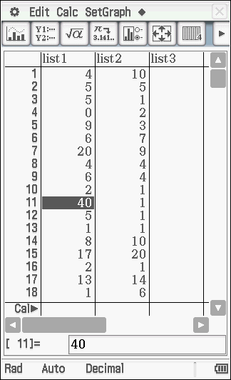 | 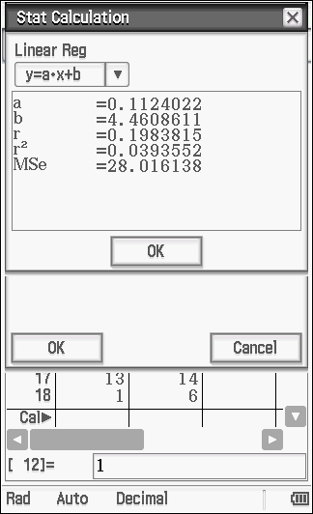
Behaviours |  | Marks | Item*  (S/C)
Calculates r the correlation coefficient of linear regression  Calculates r² the coefficient of determination |  | 1  1 | simple  simple

(c) Use your measures from (b) to comment on the proposition, ‘the more hours spent by a student watching television, the less hours the student will spend doing homework’.
Solution
Since r=0.1984, the relationship is weak and positive
r² =0.0394 indicates that the Hours of television watched has a small effect on the Hours of homework done
The proposition suggests a negative relationship between Hours of TV versus Hours of homework,
but the sample here is neither negative nor strong, so does not support the proposition.
Behaviours | Marks | Item*  (S/C)
States the relationship is weak and positive  States that the coefficient of determination indicates that TV watched has only a small effect on homework done  Explains that the proposition suggests a negative relationship  States that the sample does not support the proposition | 2  1  1  1 | complex  complex  complex  complex

Question 2
The diagram below is the scatter plot for the sample in the table above.
(a) Label the axes and draw the regression line from 1(b) on the graph.

Solution
Behaviours | Marks | Item*  (S/C)
Correctly labels the axes  Uses the correct intercept on the vertical axis  Uses the correct gradient | 1  1  1 | simple  simple  simple

(b) Calculate the equation of the linear regression line, using the variables defined here:
Solution
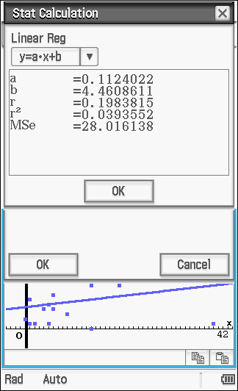

Behaviours |  | Marks | Item*  (S/C)
Defines w = the response variable  Calculates the gradient accurately  Calculates the intercept accurately  Writes the linear equation coherently |  | 1  1  1  1 | simple  simple  simple  simple

(c) Using the line of best fit in (b), calculate the residual for the student who watched 17 hours of TV and spent 20 hours doing homework.
Solution
Behaviours | Marks | Item*  (S/C)
Uses the explanatory value t=17  Calculates the response value accurately  Calculates the residual correctly | 1  1  1 | simple  simple  simple

ACKNOWLEDGEMENTS
Data from: Australian Bureau of Statistics. (2013). Retrieved May, 2014, from (2014) CensusAtSchool www.abs.gov.au/websitedbs/CaSHome.nsf/Home/CaSMa06+ARE+MALES+BETTER+DRIVERS#hello
Used under Creative Commons Attribution 2.5 Australia licence.

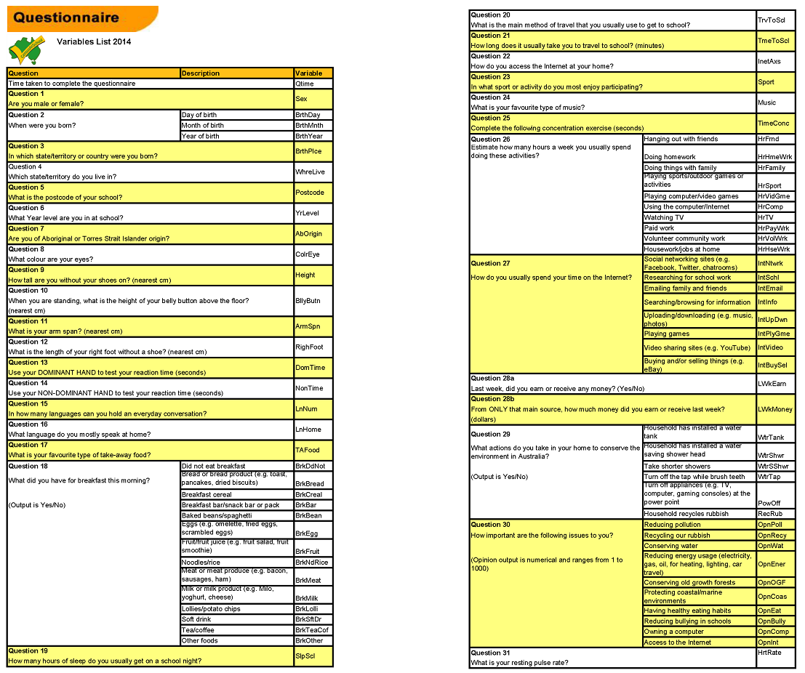
Australian Bureau of Statistics. (2014). CensusAtSchool questionnaire: Variations list 2014. Retrieved from www.abs.gov.au/websitedbs/CaSHome.nsf/Home/CensusAtSchool+Past+Questionnaires. Used under a Creative Commons Attribution 2.5 Australia licence.

Data points for Arm span versus Height for approximately 50 students, after outliers were removed

Q11. Arm span | Q09. Height | Q11. Arm span | Q09. Height
164 | 172 | 157 | 160
135 | 134 | 133 | 134
169 | 170 | 149 | 153
186 | 186 | 168 | 171
169 | 169 | 154 | 155
151 | 152 | 160 | 159
177 | 168 | 181 | 179
168 | 169 | 133 | 143
145 | 151 | 141 | 144
169 | 176 | 160 | 164
172 | 172 | 163 | 170
140 | 149 | 152 | 156
185 | 186 | 157 | 163
178 | 198 | 174 | 174
144 | 144 | 178 | 179
144 | 148 | 166 | 163
162 | 163 | 123 | 152
168 | 163 | 165 | 160
134 | 145 | 186 | 180
165 | 167 | 167 | 175
154 | 160 | 152 | 162
178 | 191 | 154 | 155
159 | 162 | 140 | 150
189 | 178 | 153 | 155
142 | 133
165 | 165
161 | 164
170 | 160

Scatter graph for Arm span versus Height for approximately 50 students, after outliers were removed

Residual plot of Actual height – Fitted height from the ~ 50 students

End of assessment

